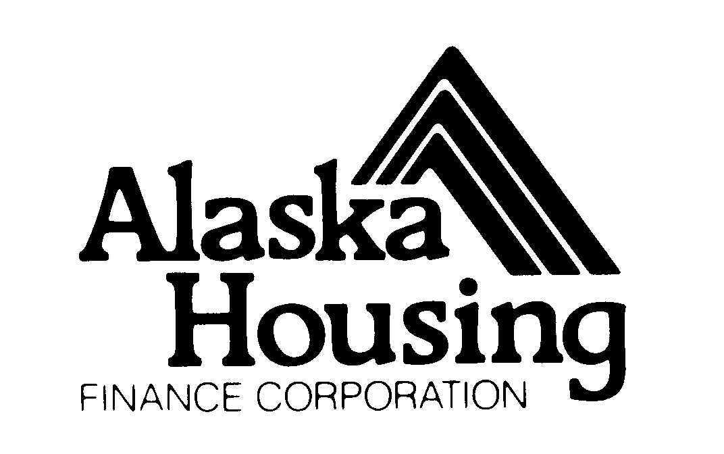 | Notice of Funding Availability  Intent to Apply  SFY26 Basic Homeless Assistance Program (BHAP) & Next Generation Stabilization Program

AHFC employs a file sharing system. Applicants must establish access to this system by submitting a completed “Intent to Apply” form. Registered users will receive an email notification that contains a link to the file sharing system. Organizations may only register one user per project.
Applicant (Organization) Name: | Project Name:
Organization Mailing Address:  Street/P.O.:  City:  State:  Zip: | Person who will submit application files:  (Only ONE person may be listed)  User’s Name:  Title:  Phone:  E-mail:
Identify which program you are intending to apply for (BHAP or Next Generation Stabilization Program): | Additional Point of Contact:  Name:  Title:  Phone:  E-mail:

Submit a completed form to: BHAP@ahfc.us

Deadline: Friday, November 14, 2025 at 4:30 p.m. Alaska Time

Questions should be directed to:
BHAP@ahfc.us
P.O. Box 101020
Anchorage, Alaska 99510
(907) 330-8255

