Alaska Housing Finance Corporation
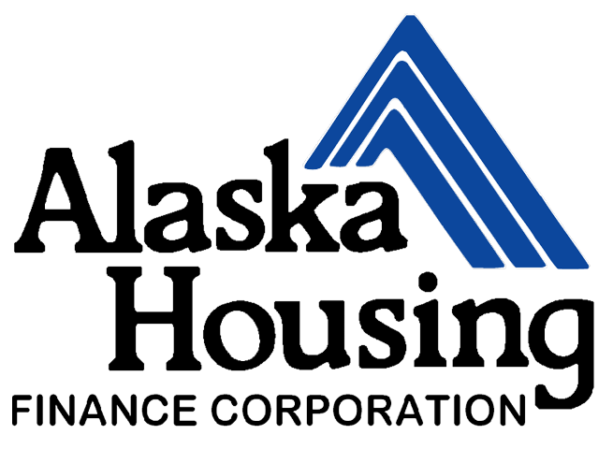

SFY26 Basic Homeless Assistance Program (BHAP)

& Next Generation Stabilization Program

Grant Coversheet

Organization Information
Organization Name:
Organization Mailing Address:
City: State: Zip Code:
UEI Number: Tax ID Number:
Contact Name: Position/Title:
Contact Phone: Contact Email:

Name of Person with Signature Authority:
Position/Title:
Phone: Email:

Board of Directors Contact Information
Name of Board Contact:
Position/Title:
Phone: Email:

Award Amount Requested:
(BHAP: Less than or equal to $100,000)
(Next Generation Stabilization Program: Less than or equal to $300,000)
$_________________

Database Information:
Please List all Databases, internal and external, where clients served through BHAP-funded programs are entered:
____________________________________________________________________________________________________________________________________________________________
*Please submit a copy of your electronic data security and collection policy(ies) for review.

Signature of Authorized Representative: ___________________________________________

Printed Name: ____________________________________ Date of Signature: ____________

Required Application Format: (FOR ALL)
- Application (BHAP or Next Generation Stabilization Program)
- Completed SFY26 BHAP Grant Coversheet
- Completed Grant Budget Worksheet
- Copies of Policies and Procedures
- Completed Eligible Activities
- Completed Organizational Chart with Board Members and Titles
- Completed Board Resolution

Required Application Format: (NEW PROJECTS)
- Completed Program Narrative
- Provide Letter of Support

Required Application Format: (COLLABORATIVE COMMUNITY)
- Complete Summary Grant Budget
- Complete Summary Grant Leverage

Required Application Format: (NEXT GENERATION STABILIZATION)
- Completed Program Narrative
- Completed Summary Grant Budget

Budget and Budget Narrative Instructions
1. Submit the completed budget worksheet through Mimecast.

Sample Budget Narrative Format
Budget Item | Amount Requested | Description
Operating Costs | $66,000 | The amount requested is 51% of the total amount budgeted for shelter utilities annually ($130,000) including electricity ($42,000), gas ($38,500), water & sewer ($33,000), trash collection ($5,500), and telephone/fax/internet. Budget amounts are based on actual utility costs in SFY23 and factoring in a 10% increase in heating costs announced on 6/10/16 by XYZ Gas Company.
Salary | $50,000 | The amount requested will fund a .6 FTE position for Case Management. Staff will work directly with clients processing intake.
Homeless Prevention-Personnel | $35,000 | The amount requested will fund a .5 FTE position. Staff to client ratio is estimated at approximately 1:11. Based on prior year’s client turnover of 90 days or less, approximately 44 households will receive prevention services.
Arrearage Assistance | $33,750 | The amount requested will be used to provide financial assistance for approximately 45 households to avert a housing crisis through payment of rent or utility arrearages. Budget amounts are based on the number served during the prior program year at an average cost of $750 per household.
Administration | $10,000 | The amount requested is within the 7.5% limitation and will be used proportionally for accounting, report generation and audit costs. (*Note: administrative activities do not cover salary for staff not directly working with participants in their program)

The threshold review consists of the following:

- The application was received by the deadline stated in section A4 of this NOFA;
- AHFC has determined that the applicant is a “responsible bidder” as described in section A of this NOFA;
- The BHAP Organization and Coordinated application forms provided by AHFC are entirely completed (with N/A appearing in areas that may not apply) and signed by the applicant’s authorized representative;
- The application contains the required resolution from the applicant’s governing body as described in section C of this NOFA; and
- Demonstration of a financially feasible program as determined by AHFC and/or review committee.
- The proposed project fits the service area as defined.

B. Evaluation Criteria: BHAP

Rating and Ranking Criteria Summary  Evaluation Criteria | Maximum  Points
1. Community Impact  - Project Fits Organization – 10 points  - Community Need – 30 points  - Defined Housing Outcomes – 10 points  - Measurable Tracking – 10 points | 60
2. Population Served  - Defined Population – 10 points  - Exceptions or Special Circumstances – 5 points | 15
3. Project Affordability  - Total Project Cost Breakdown – 30 points  - Supplemental Funding Sources – 10 points  - Location and Community Access– 10 points | 50
4. Project Characteristics  - General Housing Approach - 30 points  - Mainstream Benefits - 15 points | 45
5. New Community Bonus – 20 points | 20
Total Points | 190

B. Evaluation Criteria: Next Generation Stabilization Program

Rating and Ranking Criteria Summary  Evaluation Criteria | Maximum  Points
1. Program activities are aligned with the identified community need and prioritized to maximize the resources available to the organization. | 50
2. Sponsor capacity to collaborate. | 30
3. Appropriateness of proposed housing placement processes to address habitability of units. | 10
4. Bonus points for communities that do not currently have any AHFC rental assistance programs. | 10
Total Points | 100

