 | Release of Information to AHFC | 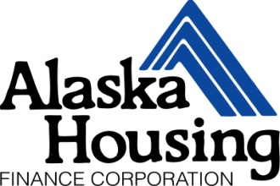

Head of Household: |  | Last 4 of SSN:
Adult Household Member: |  | Last 4 of SSN:
Adult Household Member: |  | Last 4 of SSN:
Adult Household Member: |  | Last 4 of SSN:
Adult Household Member: |  | Last 4 of SSN:

I authorize and direct housing navigators and program administrators of any Emergency Rental Assistance Program to release to the Public Housing Department of Alaska Housing Finance Corporation (AHFC) any information needed to verify my status on the Stabilization and Recovery program, legal identity to complete my application and information needed to complete my intake certification.

Inquiries that may be requested between parties include, but are not limited to:
- Length of time remaining on the relief programs i.e., Stabilization and Recovery Program
- New Start Voucher Waitlist Verification including contact information
- New Start Voucher Intake Status including outstanding documents and deadlines
- New Start Voucher Shopping Status

Conditions
I understand that this authorization cannot be used to obtain any information about me that is not pertinent to my eligibility for, or continued participation in, the New Start Voucher housing assistance program. I agree that a copy of this authorization may be used for the purposes stated above. This authorization will remain in effect for 36 months from the date signed.

Head of Household Signature |  | Print Name |  | Date
Adult Household Member Signature |  | Print Name |  | Date
Adult Household Member Signature |  | Print Name |  | Date
Adult Household Member Signature |  | Print Name |  | Date
Adult Household Member Signature |  | Print Name |  | Date

