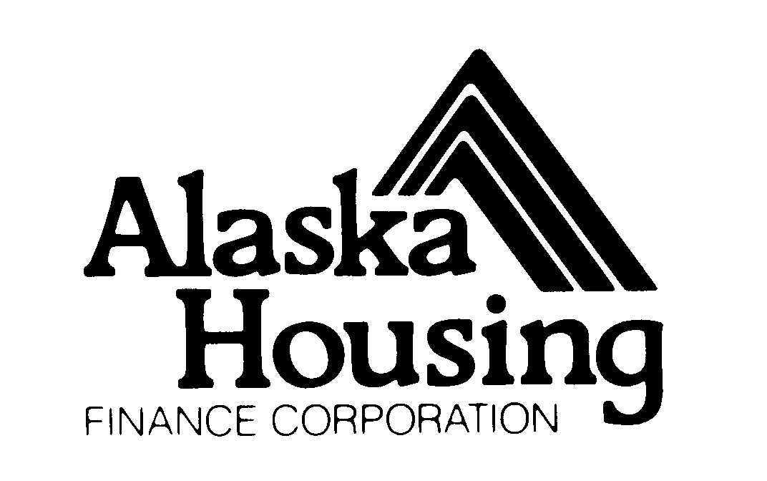 | Notice of Funding Availability  Intent to Apply

Complete the following table and submit this form to the email address below to register for the SFY 2022 Senior Access Program application round. Registration is due August 27, 2021 at 4:30 pm Alaska Time.

Organization Information | User Information
Organization Name:  Organization Type:  Phone Number:  Fax Number:  Organization Email:  Organization Address:  City:  State:  Zip Code: | User Name:  Email Address:  Phone Number:

Submit a completed form to: apetroni@ahfc.us

Questions?
Andy Petroni
Alaska Housing Finance Corporation
apetroni@ahfc.us
P.O. Box 101020
Anchorage, Alaska 99510
(907) 330-8275 office

