Step Extension Application | 

To be eligible for an extension, families must perform these steps.
- Complete this form to determine if you meet the qualifying criteria.
- Return this form along with a Family Questionnaire (PW14m), Release of Information to AHFC (VF200), and Authorization for the Release of Information/Privacy Act Notice (HUD-9886).
- Provide verification of all family income.

Head of Household Printed Name |  | Telephone Number
Housing Assistance End Date | Email Address |  | Rental Assistance Program
Housing Choice Voucher
Public Housing

Extension Qualifiers: Answer each question Yes or No

Yes | No | I received a Termination of Assistance notice.
Yes | No | My family will pay more than 50 percent of our monthly income toward rent and tenant-paid utilities when assistance ends.
Yes | No | I am compliant with my family obligations under my rental assistance program.
Yes | No | I am active in Jumpstart.

Tell us why your family is not ready to end rental assistance. For example:
- My family has work income, but it is not sufficient for my family to pay the rent.
- I am currently in a job or work skills training or educational program, but I do not expect it to complete before my current rental assistance terminates.
- One or more family members with income have permanently left my household.
- A family member’s medical or health condition is preventing a work-able adult from working or is causing a reduction in work hours for a currently employed adult.

Explain why your family will be unable to pay the rent and when you think that you will be able to pay the rent in full.

Additional Facts for AHFC to Consider
All adult household members are persons with a disability or 62 years of age or older
Other

Personal Declaration
I do hereby attest that all the information provided in this application about my household members and me is true and complete, and I have read the statements and warning below.
- I understand that I must report any changes in family composition in writing to AHFC within ten (10) business days of the change.
- I understand I must participate in Jumpstart to be considered for any extension. Jumpstart is AHFC’s Family Self Sufficiency Program that assists families who wish to increase income through employment.
- I understand work-able adults in the household must be willing to seek and obtain employment or become actively engaged in job training (any adult family member can fulfill this requirement).
- All requested documents are attached.

Warning: Title 18, Section 1001 of the U.S. Code states that a person is guilty of a felony for knowingly and willingly making false or fraudulent statements to any department of the United States Government. HUD and any owner (or any employee of HUD or the owner) may be subject to penalties for unauthorized disclosures or improper use of information collected based on the consent form.

Current Mailing Address

Head, Spouse, or Co-Head of Household Signature |  | Date
Printed Name

For AHFC Use Only Extension 1 Extension 2
Housing Staff Name | Meets Shelter Burden | Date to Jumpstart
Attachments to fss@ahfc.us:
Step Extension Application (pages 1 & 2)
Step Extension Calculator (B08)

Jumpstart Staff Name | Jumpstart Eligible? | Date to Housing
Yes
No

Release of Information to AHFC

Head of Household: |  | Last 4 of SSN:

I authorize and direct any federal, state, or local agency and any organization, business, or individual to release to Alaska Housing Financial Corporation (AHFC) any information or materials needed to complete and verify my application for, or participation in, any AHFC assisted housing program.

Verifications and inquiries that may be requested include, but are not limited to:
- Identity and Marital Status  - Family Composition and Custody  - Police Records and Criminal History  - Residences and Rental Activity  - Credit History | - Income from any Source  - Assets of any kind, including Assets Disposed of within the Last Two (2) Years  - Medical or Disability-Related Expenses  - Child Care Expenses

Groups or Individuals that AHFC May Contact
- Past and Present Landlords  - Past and Present Employers  - Courts and Post Offices  - Schools and Colleges  - Law Enforcement Agencies  - Utility Companies  - Banks and Financial Institutions  - Private Social Service Agencies  - State of Alaska Departments | - Social Security Administration  - Internal Revenue Service  - Veterans Administration  - Medical and Child Care Providers  - Retirement Systems  - Payees  - Trustees, Conservators, Guardians  - Individuals Providing References or Other Documentation

Conditions
I understand that this authorization cannot be used to obtain any information about me that is not pertinent to my eligibility for, or continued participation in, a housing assistance program. I agree that a photocopy of this authorization may be used for the purposes stated above. This authorization will stay in effect for 15 months from the date signed.

Head of Household Signature |  | Print Name |  | Date
Adult Household Member Signature |  | Print Name |  | Date
Adult Household Member Signature |  | Print Name |  | Date

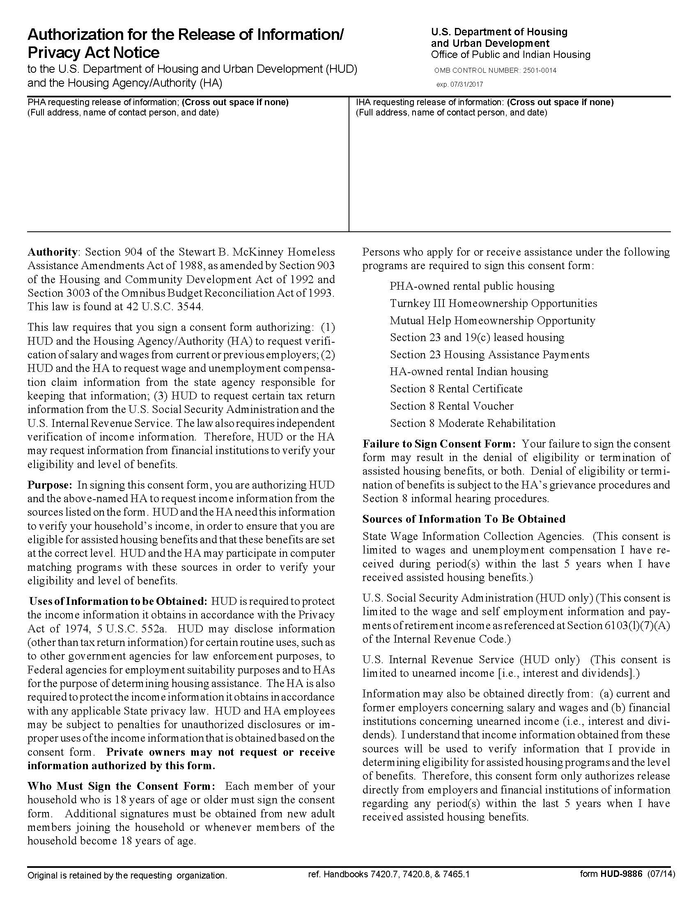

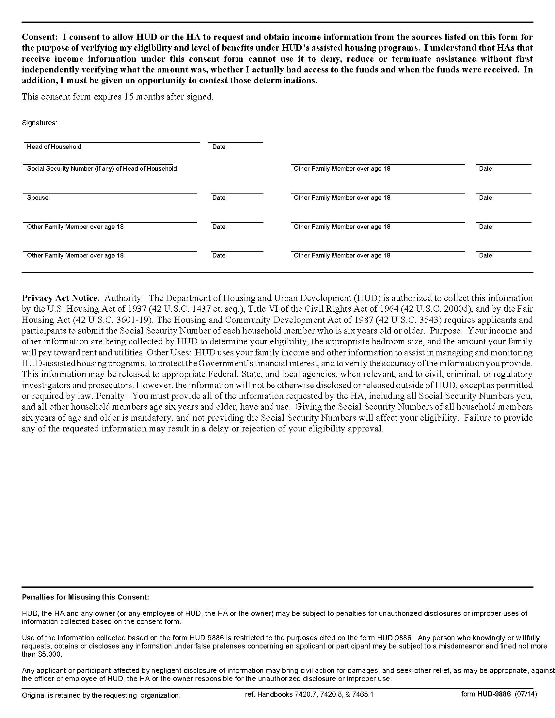

MTW Family Questionnaire
Please answer each question by filling in the box or answering “Yes” or “No”.
You may request assistance with this document from AHFC.

Head of Household
Legal Name
Mailing Address
City, ST, Zip Code
E-Mail Address

Gender: | Male |  | Female

Social Security Number
 |  |  | - |  |  | -

Date of Birth
 |  | - |  |  | -

Telephone
 |  |  | - |  |  |  | -

 |  |  | - |  |  |  | -

 |  |  | - |  |  |  | -

Household Composition - List all persons who are or will be living with the head of household. Ask for another copy of this page if you need to list additional persons.
 | Member Name | Social Security Number | Date of Birth | Relation to Head | Gender
M
F
M
F
M
F
M
F
M
F
M
F
M
F
M
F
M
F

 | Yes | No | Do you share custody of any children in the household? If yes, list them below.
 | Child’s Name |  |  | % of Time in Household | Child’s Name | % of Time in Household

 | Yes | No | Are there any household members who are temporarily absent from the home (foster care or the custody of the State of Alaska, jail (incarceration), school, military, employment, etc.)? If yes, list them below.
 | Name |  |  | Reason for Absence | Absence Begin Date

 | Yes | No | Are there any persons in your household who are over the age of 18 and students? If yes, list them below.
 | Name | School Name | Address | Reside at School?
Yes
No
Yes
No

 | Yes | No | Are there any persons in your household who are over the age of 18 and a person with a disability? If yes, list them below.
 | Name |  |  | Name

 | Yes | No | Are there any persons in your household who are over the age of 18 and under the care of a conservator or guardian or have a legal representative or payee? If yes, list them below. Please note that where required this person may have to sign all documents on their behalf.
 | Adult’s Name |  |  | Guardian’s Name | Address or Telephone

 | Yes | No | Are there any persons in your household who have had a change in their citizenship status? If yes, list them below.
 | Name |  |  | Citizenship Status | Name | Citizenship Status

 | Yes | No | Has any household member been arrested, charged with, convicted of a crime, or released from incarceration in the past 12 months? If yes, list and explain below.
 | Yes | No | Is any household member currently on a sex offender list? If yes, list and explain below.
 | Name |  |  | Explanation

Job, Work, or Self Employment Income – For each adult with this type of income, please complete the sections below. This type of income includes full- and part-time jobs, seasonal or temporary jobs, working for cash, self-employment or owning a business, and enlisted in the military. Do not list household members who are under the age of 18 and may be working (like a child’s newspaper route or babysitting).
- Include an adult here if a job has been accepted, but the work has not started.
- Include an adult here if a job is seasonal, and it is the off-season for that work.
Member Name |  |  |  | Employer Name and Address |  |  |  |  |  |  | Employer Telephone
How Often Do You Get Paid? |  |  |  |  |  |  |  |  | Gross Amount per Paycheck |  | Hours Worked per Week
Week  Month |  | Every 2 weeks  Other _____________________ |  |  |  | Twice a month  Hourly Amount _____________
Do Any of the Following Apply to This Job?
Bonus |  |  | Commission |  | Overtime |  | Tips | Self-Employed |  | Seasonal |  | Temporary
Yes  No |  |  | Yes  No |  | Yes  No |  | Yes  No | Yes  No |  | Yes  No |  | Yes  No

Member Name |  |  | Employer Name and Address |  |  |  |  |  |  | Employer Telephone
How Often Do You Get Paid? |  |  |  |  |  |  |  | Gross Amount per Paycheck |  | Hours Worked per Week
Week  Month | Every 2 weeks  Other _____________________ |  |  |  | Twice a month  Hourly Amount _____________
Do Any of the Following Apply to This Job?
Bonus |  | Commission |  | Overtime |  | Tips | Self-Employed |  | Seasonal |  | Temporary
Yes  No |  | Yes  No |  | Yes  No |  | Yes  No | Yes  No |  | Yes  No |  | Yes  No

Member Name |  |  | Employer Name and Address |  |  |  |  |  |  | Employer Telephone
How Often Do You Get Paid? |  |  |  |  |  |  |  | Gross Amount per Paycheck |  | Hours Worked per Week
Week  Month | Every 2 weeks  Other _____________________ |  |  |  | Twice a month  Hourly Amount _____________
Do Any of the Following Apply to This Job?
Bonus |  | Commission |  | Overtime |  | Tips | Self-Employed |  | Seasonal |  | Temporary
Yes  No |  | Yes  No |  | Yes  No |  | Yes  No | Yes  No |  | Yes  No |  | Yes  No

Member Name |  |  | Employer Name and Address |  |  |  |  |  |  | Employer Telephone
How Often Do You Get Paid? |  |  |  |  |  |  |  | Gross Amount per Paycheck |  | Hours Worked per Week
Week  Month | Every 2 weeks  Other _____________________ |  |  |  | Twice a month  Hourly Amount _____________
Do Any of the Following Apply to This Job?
Bonus |  | Commission |  | Overtime |  | Tips | Self-Employed |  | Seasonal |  | Temporary
Yes  No |  | Yes  No |  | Yes  No |  | Yes  No | Yes  No |  | Yes  No |  | Yes  No

Income - If any household member is receiving money from any of the sources below, check “Yes” and then fill in the Income Table below.
- If any household member is applying for or will apply for any of the sources below, check “Apply”.
- If no household member is receiving that income type, check “No”.

Yes | No | Apply | Income Source
 |  |  | Wages or Self-Employment (full- and part-time jobs, seasonal or temporary jobs, working for cash, self-employment or owning a business, or enlisted in the military)
 |  |  | Social Security (SSA, SSA-DI, Retirement, Survivor)
 |  |  | Supplemental Security Income (SSI)
 |  |  | Veteran’s benefits
 |  |  | Temporary Assistance to Needy Families (TANF) or Alaska Temporary Assistance Program (ATAP)
 |  |  | Alaska Adult Public Assistance (APA), Old Age Assistance, or Alaska Interim Assistance (IA)
 |  |  | Alaska Senior benefits (Longevity)
Benefits from another state/country
____________________________________
 |  |  | Alaska Native dividends or payments
 |  |  | Retirement or pension payments
 |  |  | Unemployment payments
 |  |  | Worker’s compensation payments
 |  |  | Foster care or adoption assistance payments
 |  |  | Alimony or child support payments
 |  |  | Disability payments not already listed
 |  |  | Grant or scholarship payments
 |  |  | Payments from any other sources

 | Income Table – For each source checked “Yes” above, describe the income below.
 | Member Name | Income Name or Source | How Often Are You Paid? | Gross Amount per Payment
Week Every 2 weeks
Month Twice a month
Other _______________
Week Every 2 weeks
Month Twice a month
Other _______________
Week Every 2 weeks
Month Twice a month
Other _______________
Week Every 2 weeks
Month Twice a month
Other _______________
Week Every 2 weeks
Month Twice a month
Other _______________
Week Every 2 weeks
Month Twice a month
Other _______________
Week Every 2 weeks
Month Twice a month
Other _______________
Week Every 2 weeks
Month Twice a month
Other _______________

If you checked “Apply” to any income source above or expect any other changes, explain below.

 | Yes | No | Are there any persons in your household who did not receive the most recent Permanent Fund Dividend? If yes, list them below.
 | Name |  |  | Reason (didn’t apply, not eligible, garnished) | Alaska Driver’s License or ID

 | Yes | No | Does anyone not living in your household regularly pay any bills for your household? This includes items like groceries, cell phone bills, car payments, or utility or cable bills. If yes, list and explain below.
 | Name of Person Who Pays the Bill |  |  | Address | What Bill Does This Person Pay? | Amount Each Month

 | Yes | No | Do your household assets total more than $10,000 (include children’s accounts)?  - If the answer is “Yes”, complete the Asset Types and Table sections below.  - If the answer is “No”, you may skip the Asset Types and Table sections.

Asset Types - If household assets total more than $10,000:
- Check “Yes” if any household member (including children) has any of the asset sources and then fill in the Asset Table below.
- If no household member has that asset type, check “No”.

Yes | No | Asset Source
 |  | Own a house, real estate, or property. If Yes:
 |  | Yes | No | Do you have a Mortgage?
 |  | Yes | No | Do you receive rental income?
 |  | Stocks, bonds, or treasury bills
 |  | Certificate of Deposit (CD)
 |  | Retirement Account: 401-K, IRA, Roth IRA, PERS, Thrift savings, federal, state, or private
 |  | Trust for any household members
 |  | Checking or money market account
 |  | Savings account
 |  | College savings account
 |  | Investments (stamps, coins, etc.)
 |  | Whole life insurance policy
Other
_________________________________________

 | Asset Table - For each source checked “Yes” above, fill in the asset type, the institution’s name and address, and enter the value or amount of the asset.
 | Asset Type | Institution Name and Address | Value or Amount

 | Yes | No | Has any household member given away or sold an asset (see above for a listing of asset types) for less than its fair market value within the last 24 months? If yes, list below.
 | Member Name |  |  | Asset Description | Value of Asset Before Sale | Asset Sale Amount

Animals (AHFC-Owned Housing Only)
 | Yes | No | Are there any pets or assistive animals in your unit? If yes, please list.
 | Animal Type |  |  | Name (if applicable) or Description

Personal Certification and Notice
Warning: Title 18, Section 1001 of the U.S. Code states that a person is guilty of a felony for knowingly and willingly making false or fraudulent statements to any department of the United States government.

I understand that:
- Within ten (10) business days of the change, I must report and provide documentation of:
- Any change to family composition (the members of my household).
- Any change to my mailing address or telephone contact information.
- Except for birth or adoption, I may not move anyone into my unit without AHFC’s prior written approval.
- I may report any decreases in income that occur between the signature date of this document and the effective date of my examination (see attached letter for the examination effective date).

I hereby certify under penalty of perjury under the laws of the United States of America and the State of Alaska that all of the information contained in this document is true and complete. I understand that making false statements on this document is a crime under state and federal law, which may result in termination from the program and criminal prosecution.

Head, Spouse, or Co-Head of Household Signature | Printed Name | Date

If a translator or translation service, AHFC staff, or other assistance was used to prepare this questionnaire, please list below.

