|  |  |
| --- | --- |
| Mobile Home Tie Downs | ahfc_logo_large.jpg |
|  |

The Department of Housing and Urban Development (HUD) has designated Alaska to be a high wind area. For a mobile home to meet Housing Quality Standards (HQS) in a high wind area, it must have tie downs. Mobile homes that do not have tie downs are not eligible for any rental assistance payments.

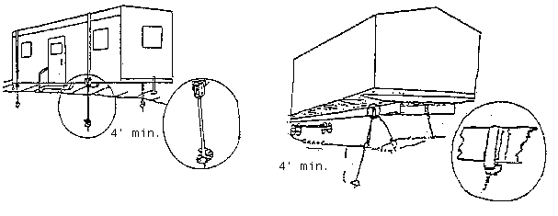

The HQS requirements state that mobile homes must be placed on a site in a stable manner and be free from hazards such as sliding and wind damage. Mobile homes must be securely anchored by a tie down device, which distributes and transfers the load imposed by the unit to appropriate ground anchors, in order to resist overturning caused by wind or sliding.

If the tie downs are attached to the frame under the mobile home, the skirting must be removed for the inspector to check installation visually. No allowances are made for weather conditions.

Tie downs must be pre-manufactured. Homes manufactured after 1976 must have the mobile home installation instruction booklet available for the inspector at the time of the HQS inspection. The following chart is a guide for required number of tie downs for mobile homes manufactured prior to 1976.

|  |  |  |
| --- | --- | --- |
| Length of Mobile Home | Number of frame ties per side | Number of over the top ties |
| Up to 46 feet | 4 | 2 |
| 46 feet to 49 feet | 5 | 2 |
| 49 feet to 58 feet | 5 | 3 |
| 58 feet to 70 feet | 6 | 3 |